Trip management plan: Hurunui River Section from A to B Grade 2

Total length of trip _________km

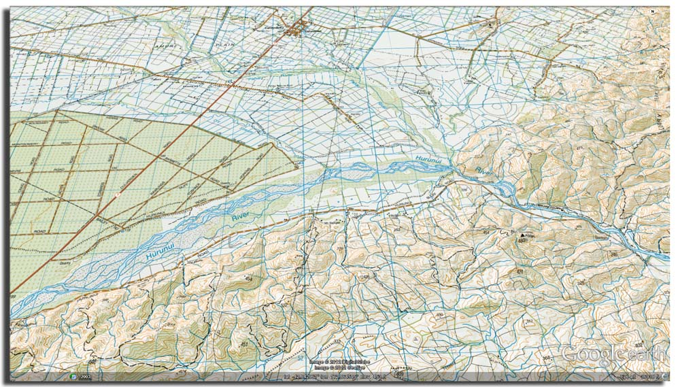

Key
Escape options:
1 Horses Rd
2 Pond Rd
1
A
B
2
1
2

Major known hazards:
- Blobs Sieve
- Megs drop
No cell phone coverage

Key Operational Information

Activity |  | Brief description of activity and use for different clients |  | Location | Include Grid references if relevant
Communication equipment and coverage |  | eg: radio, cell phone, EPIRB  Information regarding cell / radio coverage for the area |  | Access permission information | Land-owners specific instructions prior to going: conditions of use, contact numbers eg: Bob Jones 756432 for river access to start of trip, contact a day before using.
Specific operation policies |  | Key operation policies for the activity:  - Minimum age 12, maximum number in raft 6, minimum number of rafts 2  - Cut offs eg: River Level, 35 cumecs. When triangle rock covered, it is a No Go. Above 25cumecs must have a safety kayaker accompany trip.  - Call in after Blobs Sieve portage |  | Other information relevant to activity | eg: easterly wind slows trip down considerably  Alternative options for a trip put-ins or take-outs if want to shorten / lengthen it
Previous relevant incidents |  | Incidents that will enhance learning eg: swimmer recirculated in Harrys Hole at 58 cumecs |  | Escape options | 1 Horses Rd GPS coordinates, river left, left braid onto access road  2 Ponds Rd GPS coordinates, river right, private access Sam Smith’s property, access approved for emergency take out
Specific emergency equipment required |  | Safety and emergency response equipment required as per policy eg: sweep kit, throw bag, first aid |  | Emergency response | Site specific information eg: other operators that work in this area that could help,  local medical services numbers
Safety Management
Map key number | Significant Hazard |  |  | Management Strategy
1 | Blobs Sieve |  |  | Compulsory portage at all flows river right GPS coordinates........call to base once complete
2 | Megs Drop |  |  | Run river right, cover eddy river right
Approved by: |  |  | Date: | Review due:

