.



Low Ropes and
Confidence Courses
Good Practice Guide

Version 2

2021

Low Ropes and Confidence Courses
Low ropes and confidence courses involve fixed structures that are often built within camp environments and/or outdoor centres to create challenges of varied levels of intensity.

These structures may be built using a mix of wood, cables, ropes, pipes and tyres. They usually involve height and can incorporate elements of climbing, traversing, swinging, jumping, falling, crawling, balancing and sliding. They may be linked or they may be stand-alone activities.

Participant safety is not managed by an additional physical safety system (rope, harnesses, nets, etc), but should be managed by clear instructions for use, effective supervision and will often involve physical spotting to help manage a fall.

These structures are primarily used for educational and developmental programmes and can involve individual or team challenges. For guidance on activities that do not involve fixed structures refer to the Adventure Based Learning Activities Good Practice Guide.

This GPG covers situations where participants are being closely supervised by a designated leader and is not intended to cover unsupervised or free-time use.

Activities that are intended for unsupervised use should comply with NZS5828:2015 Playground Equipment and Surfacing.

Note: Considering the level of risk involved, ropes or confidence course elements that allow a fall of more than 2000mm may be subject to the Health and Safety at Work (Adventure Activities) Regulations 2016.

This GPG does not cover cableway activities, which can be classified as either:
- Flying foxes: that usually operate without supervision and should comply with NZS5828: 2015 Playground Equipment and Surfacing.
- Ziplines: that should comply with the High Wire and Swing Activity Safety Guideline and are likely to be subject to the Health and Safety at Work (Adventure Activities) Regulations 2016.

This guidance is specific to Low Ropes and Confidence Course activities and is designed to be used in conjunction with the General Guidance for Organised Outdoor Activities and the Low Ropes and Confidence Courses Planning Template.

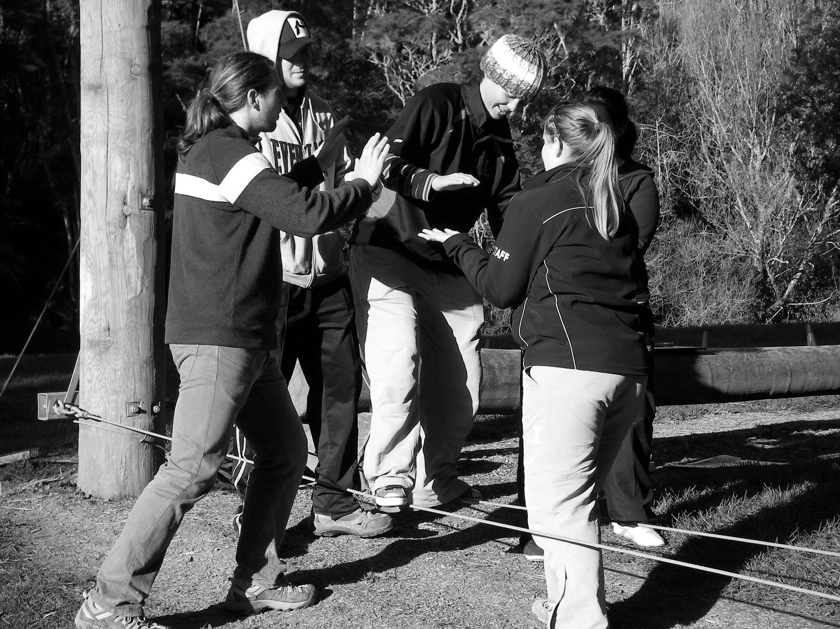

Potential value of activity

LOW ROPES AND CONFIDENCE COURSES CAN PROVIDE OPPORTUNITIES FOR PARTICIPANTS TO:

- Learn how to work together to achieve tasks
- Overcome challenges - as individuals and/or together
- Increase their awareness of, and respect for, each other’s strengths
- Develop better relationships with each other and others, e.g., their teachers
- Develop their confidence and self esteem
- Experience different teaching styles and learning contexts
- Develop their team leadership skills
- Meet goals associated with the curriculum.

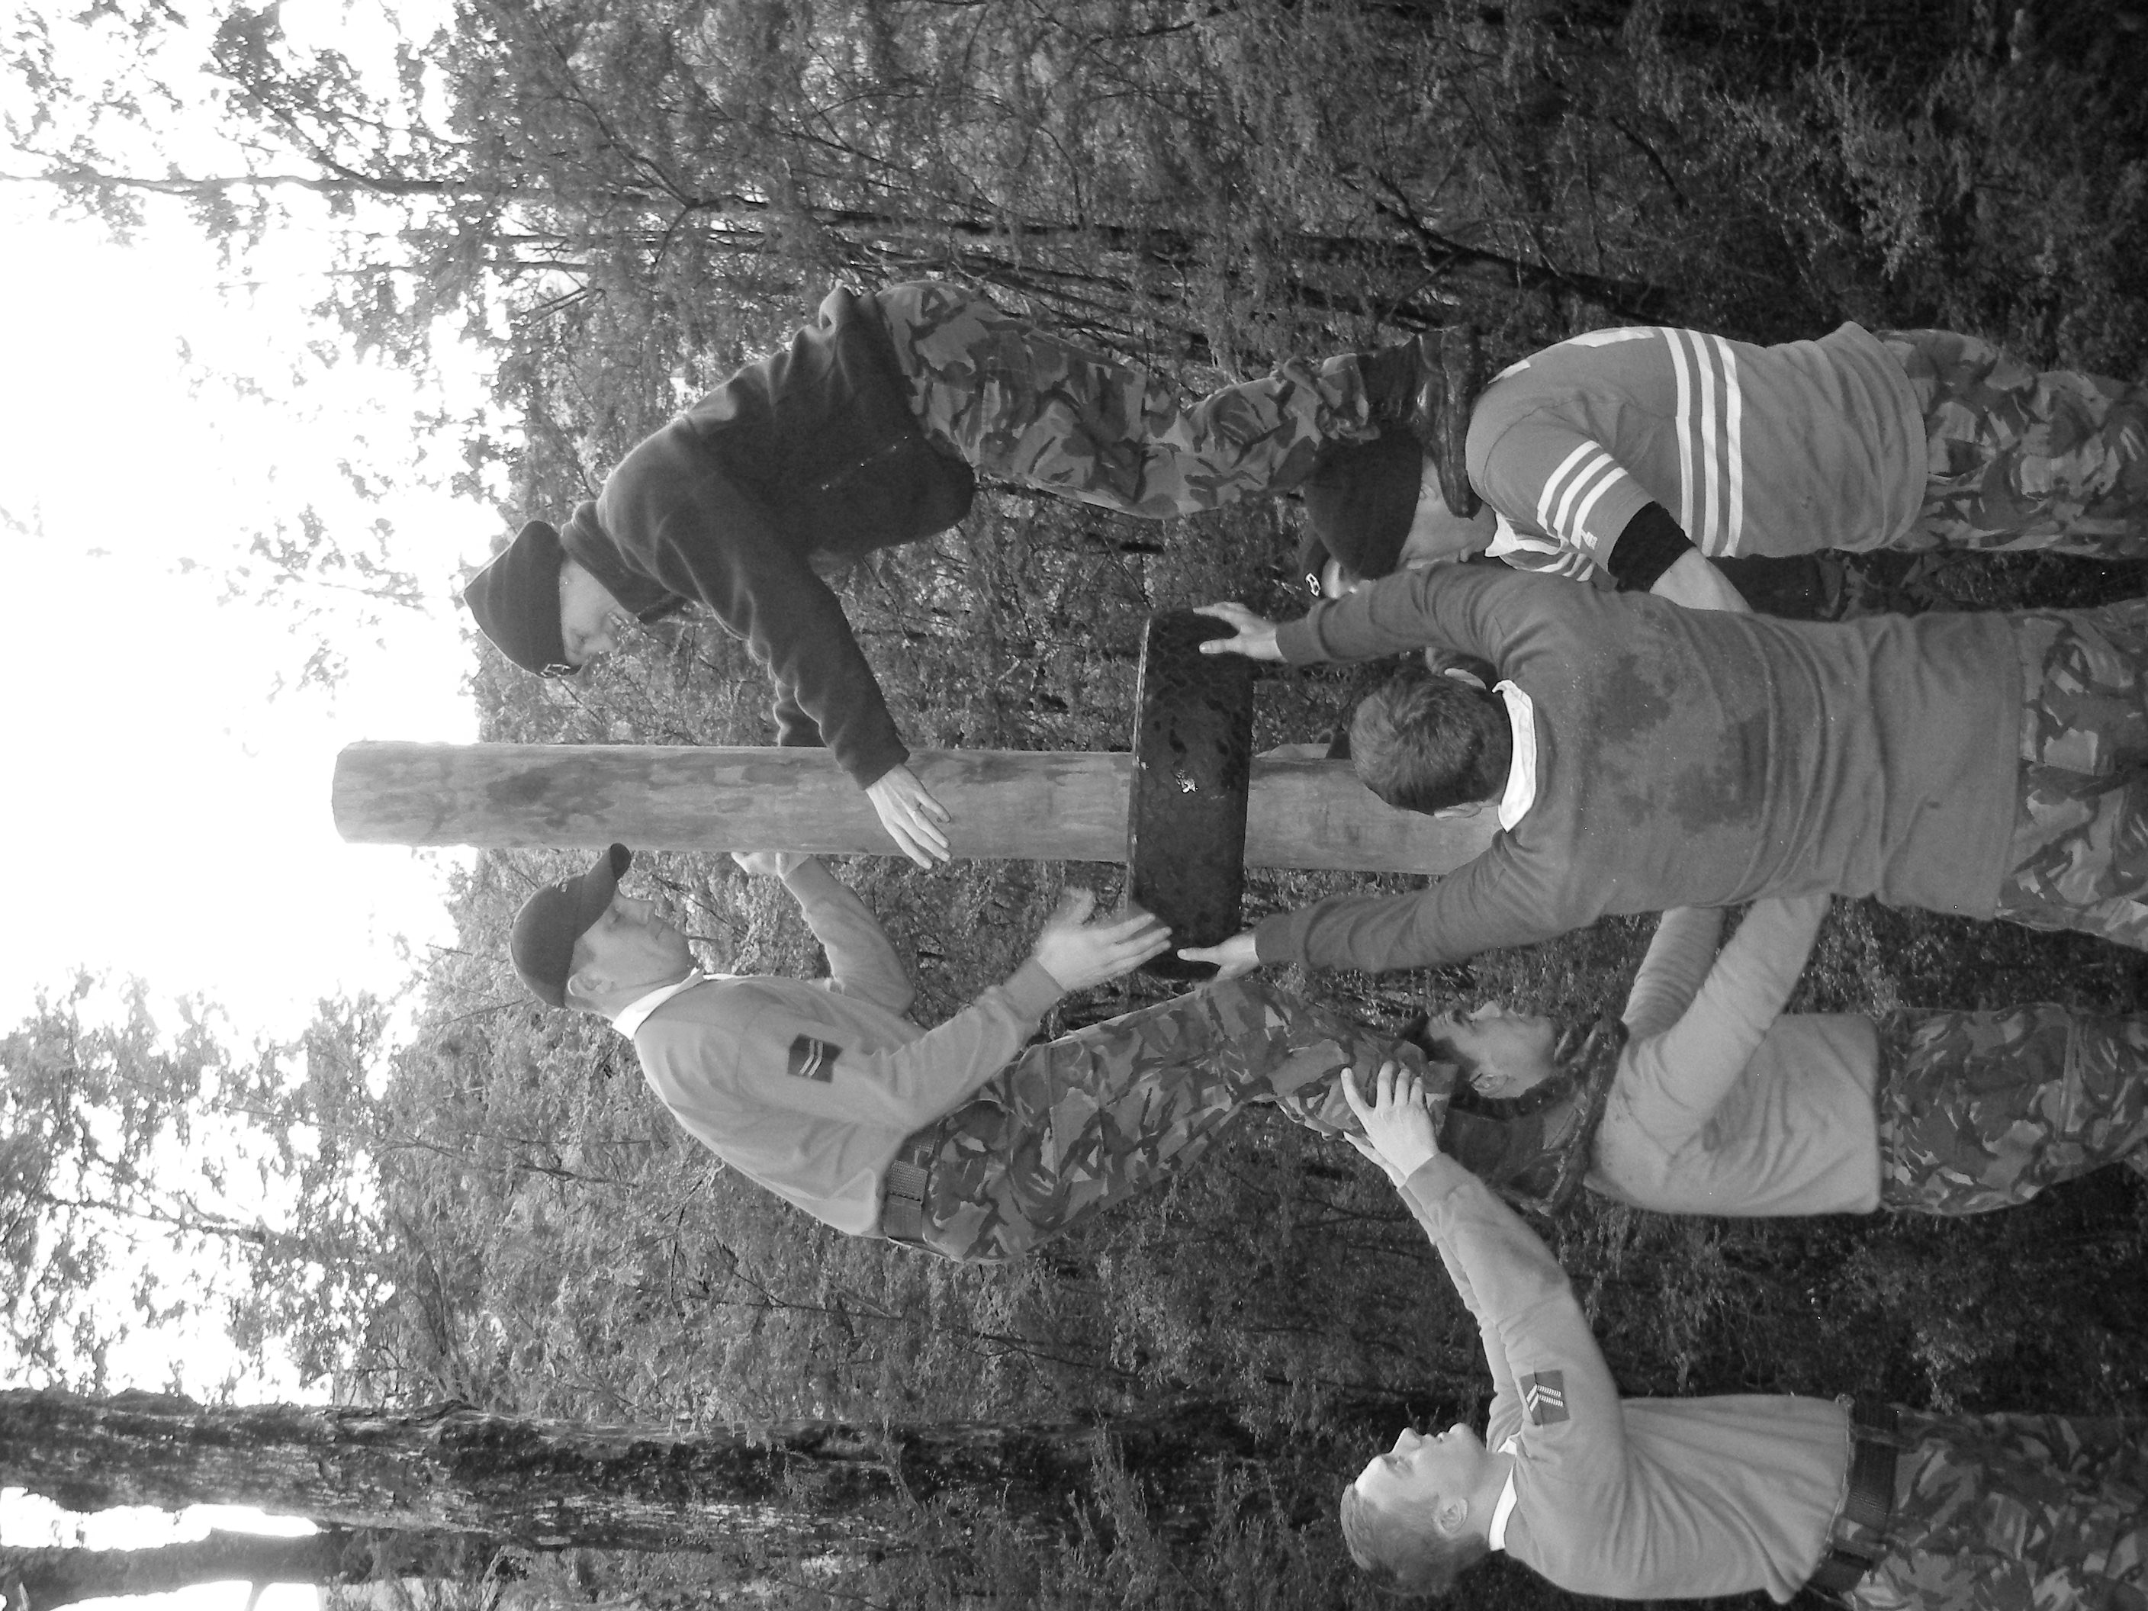

“You can learn more in an hour of play, then you can
in a year of conversation”

Planning considerations
In addition to the generic considerations (see General Guidance for Organised Outdoor Activities) consider:

- The design, build, maintenance and inspection of the low ropes and confidence course activity:
  - Low ropes and confidence course structure(s) should be designed and built to:
- Limit free height of fall to no more than 2000mm*
- Reduce likelihood of impact with structure, fittings, concrete footings etc
- Include impact-attenuating surface, e.g., 300mm bark*
- Comply with building regulations, and local body requirements.

* Note: Where no suitable impact-attenuating surface is provided the free height of fall should be limited to no more than 1500mm.

  - The facility should be well maintained and inspected every 3 - 6 months (dependent on use or seasonality). Inspections must be recorded and include a particular focus on critical connections and moving parts.
- The low ropes and confidence course should have clear operating parameters, e.g., maximum safe weights, number/age of participants, operational instructions, safe zones, and emergency assistance information.
- Operators that are hiring another organisation’s facilities should:
  - Check maintenance and inspection records
  - Ensure they receive all relevant operational information
  - Check that their risk assessment and operating procedures are aligned with those of the facility’s owner.
- Sequencing of activities
  - Outcomes: what do you hope the participants will learn?
  - How will the activity be briefed and frontloaded, and how will participants be guided to process their experience during and after the activity?
  - The activities should build on challenge, skills and concepts.
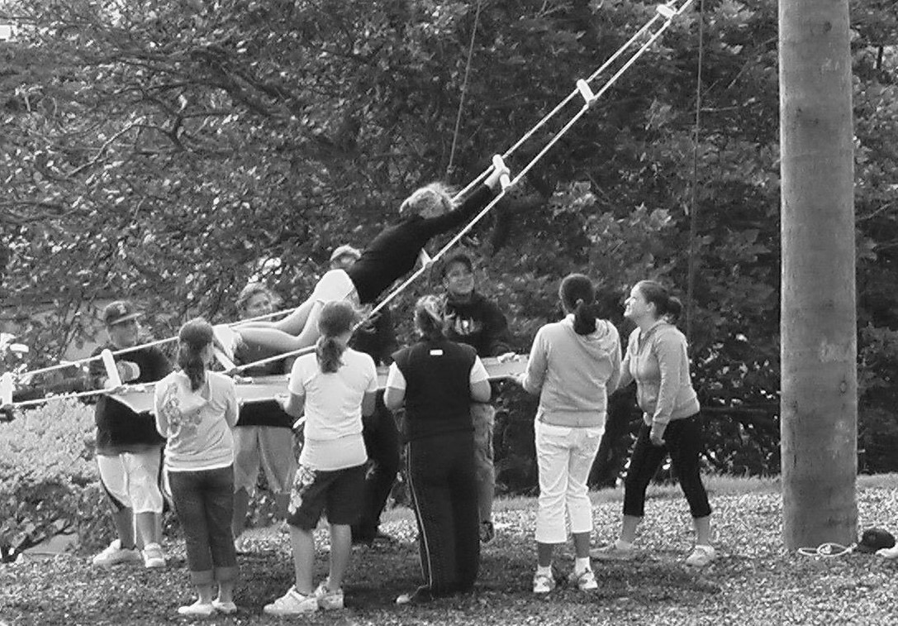

Participants
How to ensure the activities match the participants’ abilities and needs.

In addition to the generic participant considerations (see General Guidance for Organised Outdoor Activities) organisers of low ropes and confidence course activities should consider:

- Do the participants have sufficient fitness and mobility to be able to undertake the planned activities?
- Can participants be relied on to carry out safety sensitive tasks (either as participant or spotting)?
- Consider sequencing trust and spotting activities so that participants can demonstrate reliability, before moving to elements with high safety consequences.
- Consider what variations could be implemented if a participant has taken part in the element or challenge before.

Supervision
The level and style of supervision typically required for this activity.

CONSIDER THE FOLLOWING WHEN DETERMINING THE APPROPRIATE SUPERVISION STRUCTURE FOR LOW ROPES AND CONFIDENCE COURSE ACTIVITIES:

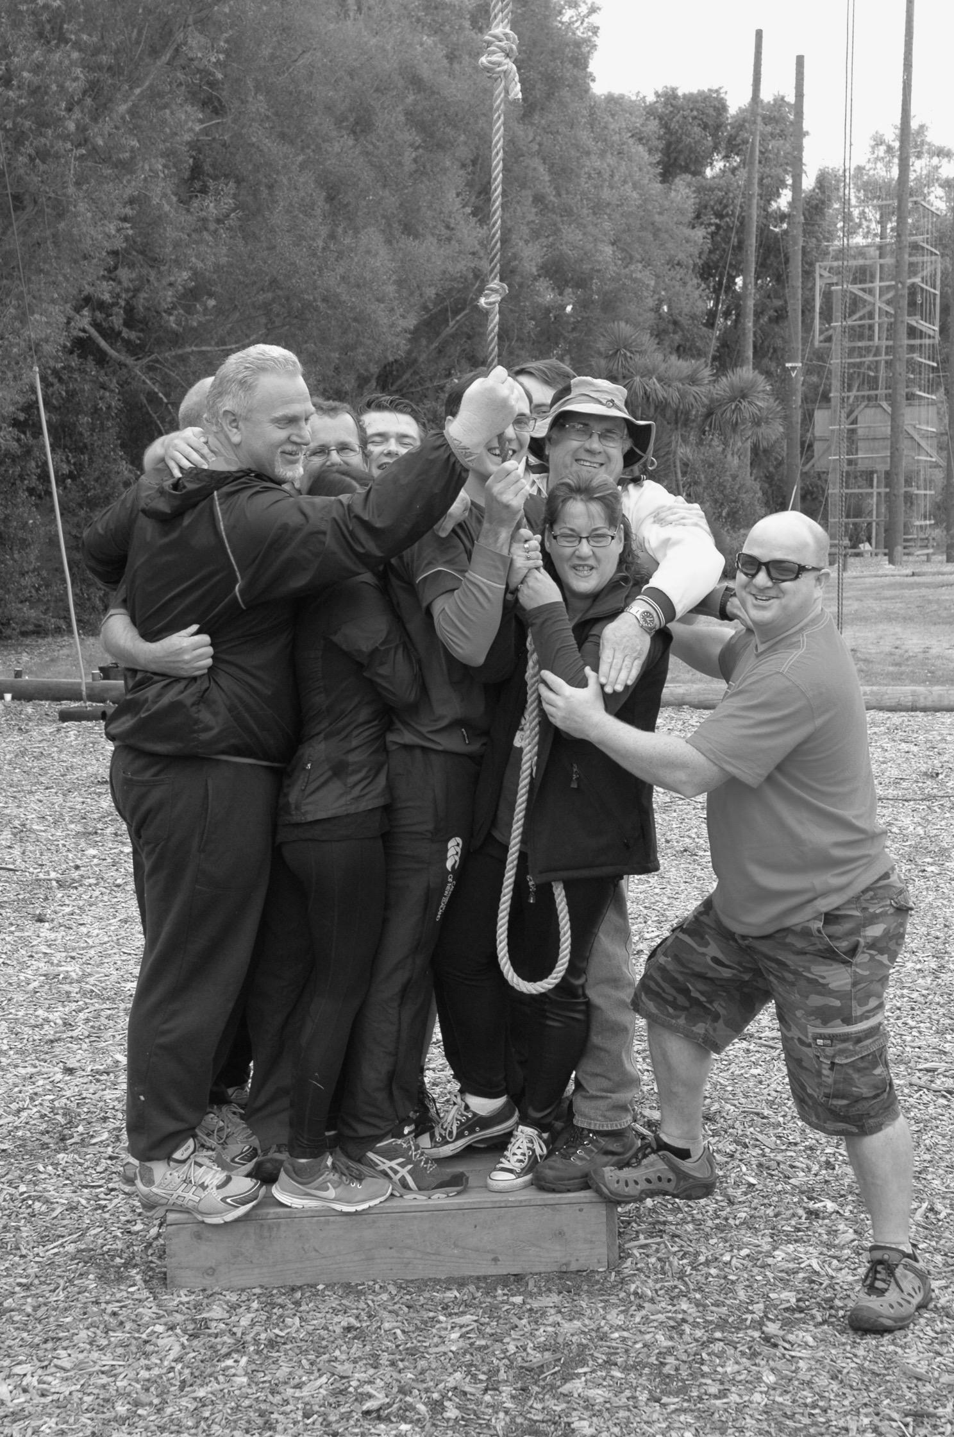
- The need to understand each activity, including its risks and challenges
- Use sufficient leaders to ensure that participants can be supervised at a level where leaders can detect and correct improper procedures
- Know where to position leaders in order to be able to intervene or provide additional support if required
- Spectators or participants that are not actively involved should not interfere with the activity(s). They should be appropriately engaged and may require additional supervision.

Leader competence
The experience and knowledge required by those running the activity, both for normal operation and for managing emergencies. What competence assistant leaders need should also be considered (e.g., where parents or other adults are helping the person running the activity).
Skills and knowledge
Requirements of a leader who is working independently, or is responsible for a larger group of activities leaders include:

- Are they familiar with the area, any site-specific requirements and emergency procedures?
- Do they understand each separate activity, including risks, challenges and instructions for use?
- Do they understand the set-up requirements and the need to conduct pre-use checks?
- Can they identify, manage and communicate hazards and risks?
- Can they prepare the group, including:
  - Their understanding of safety roles (e.g., spotting)
  - Ensuring they are appropriately clothed and equipped
  - Briefing activity outcomes and instructions?

- Can they monitor use of the activity, including spotting if required, and intervene to manage safety or behavioural issues?
- Do they understand how to dismantle the activity, report use (e.g., complete user logs) and incident reports?
Other activity leaders (including parents, other adults or trainee leaders helping to run an activity) should be operating under supervision and have received training that includes:
- Understanding the activity they are responsible for, including risks, challenges and instructions for use
- Being able to explain and monitor use of the activity, and intervene to manage safety or behavioural issues
- Understanding their role in relation to the other leaders.

Relevant qualifications
The following qualifications contain components relevant to low ropes and confidence courses:

- Unit Standard 24666 (Level 5): Instruct a programme using low ropes course activities
- Unit Standard 471 (Level 3): Assist in facilitation of a low ropes course programme for the development of participants
- National Certificate in Outdoor Recreation (Instruction) Level 4-5, with strand in Adventure Based Learning
- New Zealand Certificate in Outdoor Leadership (Level 4 - Leader) with strand in High Ropes
- New Zealand Certificate in Outdoor Leadership (Level 5- Instructor) with strand in High Ropes

Resources and equipment
Consider what equipment and resources are required to run the activity safely. The participants may be required to bring this, or it may be provided to them.

Participant

- Personal clothing should be suitable for active participation, and for the weather conditions
- Consider tying long hair up, limiting loose clothing and jewellery, and ensuring pockets are empty
- Closed footwear may be necessary
- Personal medication (EpiPen, asthma inhaler), sunblock and insect repellent
- Sufficient water and food.

Leader

- Site map and information (e.g., instructions for using the venue, emergency evacuation information)
- Activity specific operating procedures
- Group medical and contact information
- Communications device
- First aid kit.

Venue

- Activity leaders should have confidence in the integrity of the activities/structure(s) they are using. This may involve checking the venues maintenance plan and inspection records.
- The surrounding area and grounds should be suitable. Identify any potential hazards (e.g., fallen branches, slippery or sloping surfaces).
- Any additional portable equipment (e.g., planks, tyres, ropes) needs to be fit for purpose.

Further support

Places to gain more information from.

High Wire and Swing Activity Safety Guideline (ASG)
The High Wire & Swing ASG is published by Tourism Industry Aotearoa with support from WorkSafe New Zealand and describes what high wire and swing operators and technical experts consider is good practice for actively managing safety in providing commercial high wire and swing activities in New Zealand.

Playground Standards
NZS5828:2015 Playground Equipment and Surfacing aims to ensure playgrounds are well designed, well-constructed, innovative and challenging. It is aligned with the European Standard, EN1176:2008 and features four appendices specific to New Zealand.

“The Playground People Pink Book” – a New Zealand guide to playground equipment and under
surface safety.
https://www.playgrounds.co.nz/media/1466/playground-people-pink-book-all-you-need-to-know.pdf

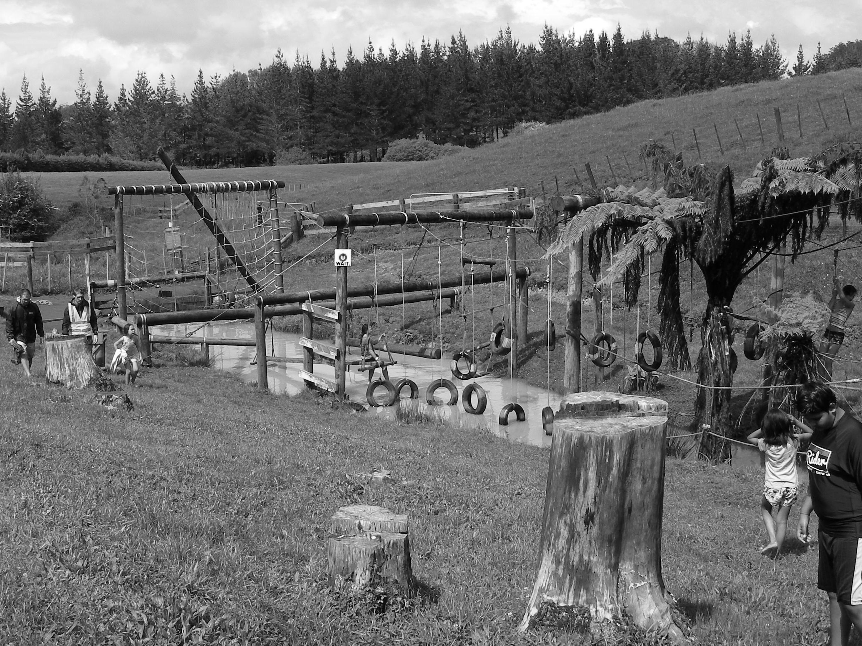

 Low Ropes and Confidence Courses Planning Template

 Overarching Risk Management Guidance

Definitions
Confidence Course
A confidence course in this context is also often referred to as an obstacle course and is a series of challenging physical obstacles that an individual or team attempt to navigate. They can include running, climbing, jumping, crawling, and balancing elements with the aim of testing confidence and physical competence.
Free Height of Fall
Distance from clearly intended body support or position to the impact area, e.g., standing = foot to surface; sitting = seat to surface; hanging = hand support to surface

Impact Attenuating
Impact attenuation of ground surfacing material is the measure of its shock absorbing properties. An impact attenuating fall zone is a safety management strategy that may or may not be used in conjunction with spotting.

Low Ropes
A low ropes course usually involves a series of elements or activities of a height where the participant’s safety is managed by other participants spotting and a belay safety system is not required. Elements involve fixed apparatus (e.g., poles/trees, cables, ropes) designed to provide challenges for participants. Activities generally fall into three categories: traversing elements, lifting elements and swinging elements. While some activities offer simple low-risk problems others require a high level of group cohesion and trust before they should be attempted.

Spotting
Spotting is a safety management technique with the primary role of helping prevent injury caused by a participant’s impact with the ground, equipment or other people. Particular attention is paid to protecting the participant’s head and upper body by physical support as required.

