National Outdoors

Incident Reporting (and Response) System

Strategic Proposal

Overview of Outcomes

Summary Plan for moving forward

Outdoors New Zealand

Version:

May 2013

# Executive Summary

The report on the Review of Risk Management  and Safety in the Adventure  and Outdoor Commercial Sectors in New Zealand, published in June 2010, recommended a number of initiatives to increase the assurance of safety in the Adventure Activities sector. The review team strongly recommended, as part of a complementary approach to safety management, an initiative to provide “better information collection and collation.”

The report also suggested an integrated approach to achieving this, involving three key components:

* Collecting better information
* Collecting consistent information
* Improving systems of collation.

*The relevant observations and recommendations from the report are in Appendix 1.*

This document provides an overview of the strategic approach Outdoors NZ is proposing (in collaboration with MSC and EONZ) in order to develop an effective national Incident Reporting System (IRS) for the NZ outdoors. We are proposing a comprehensive system-based approach that doesn’t just collect and report data, but provides a coordinated and practical response strategy that ensures positive changes in safety management behaviour.

This approach will also ensure that the limited resources available to the project, and within the sector, are focused on strategies and outcomes that will be the most effective in ensuring the IRS provides tangible improvements in safety knowledge and risk management.

## Key Elements of the national outdoors Incident Reporting System

The strategic intent is to provide a cohesive and holistic solution that enables incident and activity information to be identified and **collected**, the **co-ordinated** development of risk management strategies and the sharing of actionable and relevant **responses** through education and development opportunities to operators and outdoors professionals across the sector. The result: continuous positive changes in safety management behaviour!

### ****1. Collect****

Collect and collate information from across the sector, from local and international research and from other industries in a way that will provide insight and guidance into establishing, maintaining and monitoring safe practises. The collection mechanism for this is likely to involve some technology, including the provision of collection tools, collation mechanisms and the maintenance and accessibility of learning material.

### ****2. Coordinate****

In order to ensure that effective responses are put in place when an issue or potential concern is identified, there needs to be a co-ordination entity. The role of this body would be to manage the responses so that action is prioritised appropriately and resources are aligned to deliver the best outcomes.

This co-ordination function should ideally be supported by a sector advisory or consultative group. This would provide both guidance and a practical conduit back into the sector in such a way as to create maximum influence.

### ****3. Respond****

Responses need to be tangible, actionable, timely and relevant. They need to include education processes, communications mechanisms, skills development and, as needed, regulator intervention.

These response options dovetail into the resources and initiatives being developed as part of the Adventure Activities Regulations (the regulations, supportadventure.co.nz. ASGs, the audit standard, the audit scheme rules, etc.) and existing sector activities (ONZ roadshows, The Outdoors Forum, MSC safety publications, etc.). As such, some of the fundamentals are already in place and the system will be developed with better information and improved co-ordination, ensuring we are able to deliver behavioural change.

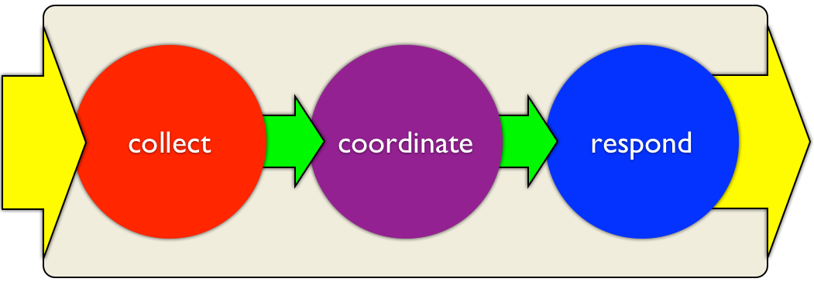

## Key Outcomes of the national outdoors Incident Reporting System

**The key outcomes for the national Incident Reporting System are to:**

* **continuously improve the safety of outdoor activities, and**
* **build a positive and dynamic safety culture in the outdoors.**

**The IRS will allow all operators to:**

* Easily and regularly report near misses and incidents

**So that they can:**

* Generate safety management information at an organisational level
* Share incident information at an activity or regional level, and receive guidance on, and solutions to, common and/or critical issues and actionable best practice
* Share information at a national level, comply with regulatory requirements and receive advice on, and solutions to, common and/or critical issues and best practice

**So that they will:**

* Receive valuable and actionable best practice safety management guidance
* Make any necessary changes to their operations and safety practices to ensure that safety management is optimised
* Contribute to the body of evidence needed to drive the continuous improvement of safety standards across the sector

## Next Steps

1. MBIE approval of this strategy.

**Once this IRS strategy is approved, we will:**

1. Conduct final project scoping to determine sector needs, integration opportunities and technology and delivery solutions
2. Provide a project development plan and costings
3. Engage appropriate sector stakeholders for support and integration
4. Deliver a comprehensive plan for the implementation of the project including technology, communications and ongoing change mechanisms
5. Establish clear outcome and output measures for the ongoing monitoring and improvement of the strategy

Contents

Executive Summary i

Key Elements of the national outdoors Incident Reporting System i

1. Collect i

2. Coordinate i

3. Respond i

Key Outcomes of the national outdoors Incident Reporting System ii

Next Steps iii

Desired Outcomes 1

1. Collect 1

2. Coordinate 1

3. Respond 1

Current Situation 2

Uncoordinated Programmes 2

Governmental 2

Commercial 2

Educational 2

Community 2

Strategic Approach 4

1. Collect 4

2. Coordinate 5

3. Respond 5

Process for Development 7

Costing Overview 8

Appendices 9

Appendix 1 – The Adventure Activities Review Report 9

Appendix 2 – Key Components to Improving Safety Culture 12

Participation Data 12

Clearer Information 12

Key actions to improve the national reporting safety culture 12

Appendix 3 – Technology Overview 13

Appendix 4 – Detailed IRS System Diagram 14

Appendix 5 – Case Studies 15

Ski Fields information 15

NZ Forestry Industry 15

# Desired Outcomes

**The key outcomes for the national Incident Reporting System are to:**

* **continuously improve the safety of outdoor activities, and**
* **build a positive safety culture in the outdoors.**

This will be done by identifying clear patterns of behaviour, activity or circumstance that lead to both positive and negative safety events. And by developing a network-based approach to collection, coordination and response, so that shared learning and collective education leads to positive changes in safety management behaviour.

### 1. Collect

##### Better collection and collation of incident data and information

Information collection will be supported by technology allowing it to be gathered in ways that are more consistent, accurate, convenient and timely; and in encouraging participation and engagement in the reporting system.

### 2. Coordinate

##### More consistent and coordinated analysis and review of information

Once the information is collected, it needs to be analysed and safety improvement actions identified by a specific sector-wide body so that the appropriate responses are coordinated and appropriate. The coordination body will also be the network by which the responses are delivered.

### 3. Respond

##### Actionable and timely responses based on the information

Once developed, we need to provide education and training opportunities that lead to meaningful changes in behaviour. So actionable and timely responses need to be delivered in a timely and meaningful way across a range of learning and communication opportunities. The responses may occur at a range of levels, from sector strategies through to specific operator actions and will need to be supported by and delivered across the whole sector to ensure that standards are raised universally.

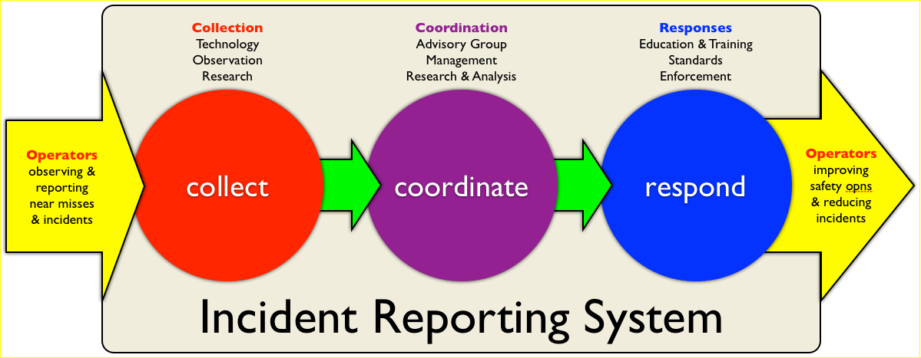

# Current Situation

## Uncoordinated Programmes

A number of valuable initiatives have already been set up within and around the outdoor sector to support the reduction in accidents and injury for outdoor participants. These sit in a number of areas within the sector: governmental, commercial, educational and volunteer/community. However, these are not well coordinated, do not often share information and are not consistently rigorous.

Included below are the key examples:

### Governmental

* MBIE’s registration database for the Adventure Activities regulations
* The safety audit standard and auditing scheme for Adventure Activities
* Accident and coronial records managed by MBIE, Maritime NZ, NZ Police and ACC
* Guidance resources created around the Adventure Activities Regulations
* Incident and search response systems managed by Coast Guard, LandSAR and the NZ Police

### Commercial

* The National Incident Database (NID) managed by Mountain Safety Council
* Ski Field incident reduction project – umbrella-ed under the NID and supported by the Ski Fields Association and ACC
* OutdoorsMark safety accreditation and auditing managed by Outdoors New Zealand
* Vocational skills and training programmes delivered by a number of commercial and voluntary organisations and supported by NZQA standards through Skills Active
* Commercial skills training and assessment programmes delivered by a number of organisations including NZOIA, NZMGA and a range of tertiary providers
* Professional development training and resources provided by Outdoors NZ, through workshops, conferences, communications & online tools
* The safety audit standard and auditing scheme for Adventure Activities
* Guidance resources created around the Adventure Activities Regulations

### Educational

* The NID
* Education Outside the Classroom (EOTC) guidance and professional development resources provided by the Ministry of Education and EONZ
* OutdoorsMark safety accreditation and auditing managed by Outdoors New Zealand
* Skills training and assessment programmes delivered by a number of organisations including NZOIA, NZMGA, MSC and a range of tertiary providers
* Outdoors NZ professional development training & resources

### Community

* The NID
* OutdoorsMark safety accreditation and auditing managed by Outdoors New Zealand
* Skills and training programmes delivered by voluntary organisations and supported by NZQA standards through Skills Active
* Recreational skills training and assessment programmes delivered by a number of organisation including NZOIA, NZMGA, MSC and a range of tertiary providers
* Outdoors NZ professional development training & resources
* Drownbase records managed by WaterSafety NZ
* Incident and search response systems managed by Coast Guard, LandSAR and the NZ Police

Integrating these valuable initiatives together and establishing a holistic system of provider-generated incident reporting will create enhanced opportunities to **collect data and collate information**, which will be **coordinated as valued intelligence** and then used to **develop and deliver actionable responses** that have a direct impact on reducing injury rates and serious harm risks within New Zealand’s outdoor environments.

The IRS system provides the integration between the reporting, analysis and education needs of all 4 sectors of the outdoors community.

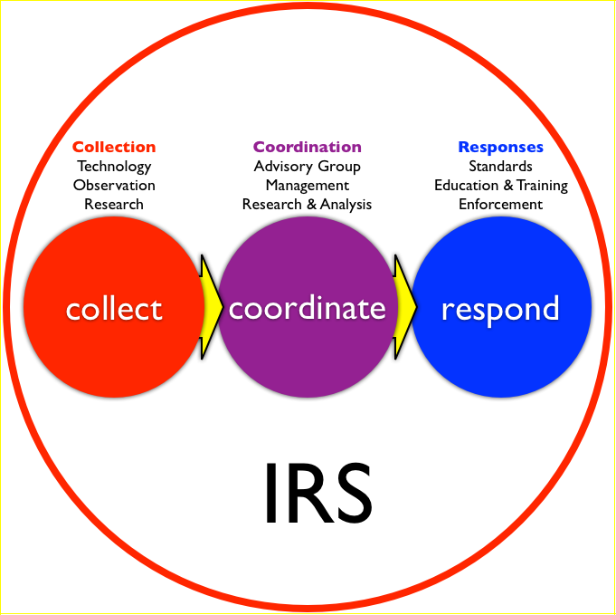

When all these initiatives are coordinated effectively within a cohesive system, it will enable the whole sector to work together to quickly identify current and future risks, to share hazard management strategies and deliver these effectively to where they are most needed.

To work effectively and sustainably, the process needs to involve as many key stakeholders as possible. By utilising all the sector learning, professional development and training resources, safety responses can be delivered in a more engaging, cost effective and timely manner. The strategic intent is therefore to develop coordinated and cohesive solutions that, while involving many elements of the sector, will include direct positive outcomes for commercial safety practises.

A key requirement for providing more effective and responsive guidance will be to improve the information flow. This strategy is based on a system that collects, collates and contextualizes data related to patterns or types of incidents and hazards in a timely manner.

# Strategic Approach

It is proposed that a coordinated incident reporting system be developed to inform and enable a sector wide approach to increasing safety standards.

It is important that this system:

* simplifies and encourages the **collection** of incident information;
* provides timely and meaningful analysis and **co-ordinated learning outcomes**; and
* leverages a sector wide approach to implementing actionable safety management **responses**, lessons and strategies.

In order to facilitate this process there must be an entity or organisation providing overall support and coordination. Outdoors NZ, as the peak body for the outdoor recreation community, would provide this link in collaboration with MSC (and WSNZ?). We would ensure that information collected is analysed effectively, then acted upon in a planned and managed way so that outcomes are achieved. In addition, a key stakeholder advisory group would collaborate on developing sector strategies, identifying the resources needed and ensuring commitment and prioritisation occurs so that the most important outcomes are achieved with sector endorsement and support.

Sector wide discussion and review has made it clear that this system will require a new technology solution to support the collection, collation and distribution of incident information (the NID is near the end of its life). It will also require the appropriate communication, education and regulatory support to ensure that required changes occur. To ensure that these collection and response tools are focused appropriately, and that they work together coherently, the co-ordination function is essential.

During our research we discovered that models where information collection has translated into an increase in safety are notable for effective information co-ordination. The forestry industry is an example where incident-based, localised and strategic learning are shared, and it is the co-ordination of this information that provides overall planning direction. The same is happening with the ski industry, which uses a co-ordinator to draw out the issues needing focus and the lessons learnt from the NID data. This coordination is also a feature of sectors such as aviation and maritime where individual entities and manufacturers use this information to drive their improvement processes.



### 1. Collect

The data that we are seeking to collect is primarily incident data, but also includes information on proven solutions to identified risks or hazards. The intention is to put in place a mechanism to collect a range of data including; incidents, known hazards, potential hazards and hazard mitigation, potential learning and relevant research tips. All these would be organised into libraries according to a range of criteria.

Information and learning content would be derived in part from;

* The collation of data and trend identification
* Specific suggestions or guidance written up by others in the sector
* Information added in response to triggers based on research or known subject libraries
* Video and audio clips with learning information including material from some of the international libraries and collections

### 2. Coordinate

This involves co-ordinating the stakeholder network of people and organisations with an interest in, and influence on, a safer outdoors. The role would ensure the indicators and information collected from a range of sources are brought together and cohesive response strategies are put in place. The responses would be determined by a number of factors including:

* What issues or incidents are happening
* The part of the sector where issues or incidents are happening
* The most effective responses seen in similar circumstances (determined by past evidence)

It is feasible that the co-ordination of responsive activity and the distribution of safety management information would be supported by technology. Ideally, this technology would be interlinked to the collection technology.

As part of the ongoing development of the safety culture around outdoor industry, a proactive communications infrastructure will be put in place to:

* Educate sector groups about the importance of sharing their learning related to incidents and hazards
* Assist operators to extract maximum value from the information available
* Ensure all operators are well skilled and prepared to use both the tools and information they receive

### 3. Respond

In order to achieve the outcome of lower incidents and occurrences of serious harm within the outdoors it is imperative that information collected and shared results in identifiable and/or measurable changes in behaviour. In order to respond positively to incident occurences it is important that commercial operators have the right information and skill to develop appropriate strategies to mitigate the risks or remove the hazards., or how their experiences can assist others.

Understanding how to do this effectively will require ongoing education within the sector. It is important that appropriate partnerships are in place to ensure that programmes have maximum effective reach at minimal cost.

Response strategies could involve;

* Redesign of education (including guidelines) and qualifications related to sector activity
* Targeted, operator focused information campaigns
* Safety management workshops, national and regional events
* Targeted identification of areas of change through audit processes
* Supported intervention at a national legislatory, local bylaw or regulatory level
* Online knowledge base, forum and resources
* Other systemic influences through key government agencies e.g Police, DoC

The intention is to implement a system that utilises all of the existing safety management processes and opportunities while supplementing them with more effective data collection, more timely analysis and reporting and more collaborative and integrated management responses. The key in developing a (more) effective system is improving the collation, and ensuring the rapid distribution, of information; which must then be followed by timely, coordinated, sector-wide responses.

#### Proactive safety management – preventing an incident

The key to delivering a proactive strategy is being able to identify trends in areas of potential risk and then responding to these with the appropriate management strategies. Effective responses include safety management system audits and the proactive development of appropriate qualifications.

It is likely that professional development programmes, through workshops, regional and national safety management events, and the development of knowledge resources will also be included. The objective will be to utilise these tools to embed new ways of thinking and raise standards in relation to targeted areas of concern.

As the delivery of these responses can take time, it is important that they are targeted appropriately, backed by evidence and measured both at an output and outcome level. It is likely that long-term research will influence the focus, definition and delivery of these strategies. It is also possible that given the longer time frames that a range of stakeholders may be able to engage throughout the strategies.

#### Reactive safety management – responding to an incident

While many of the strategies used above will create some impact to support reactive needs it is likely that the more urgent nature of these could require faster, more dramatic measures. In some cases this may include deliberate intervention by regulators, enforcement agencies or influential sector organisations in order to achieve focused and timely results.

#### Complete System Diagram

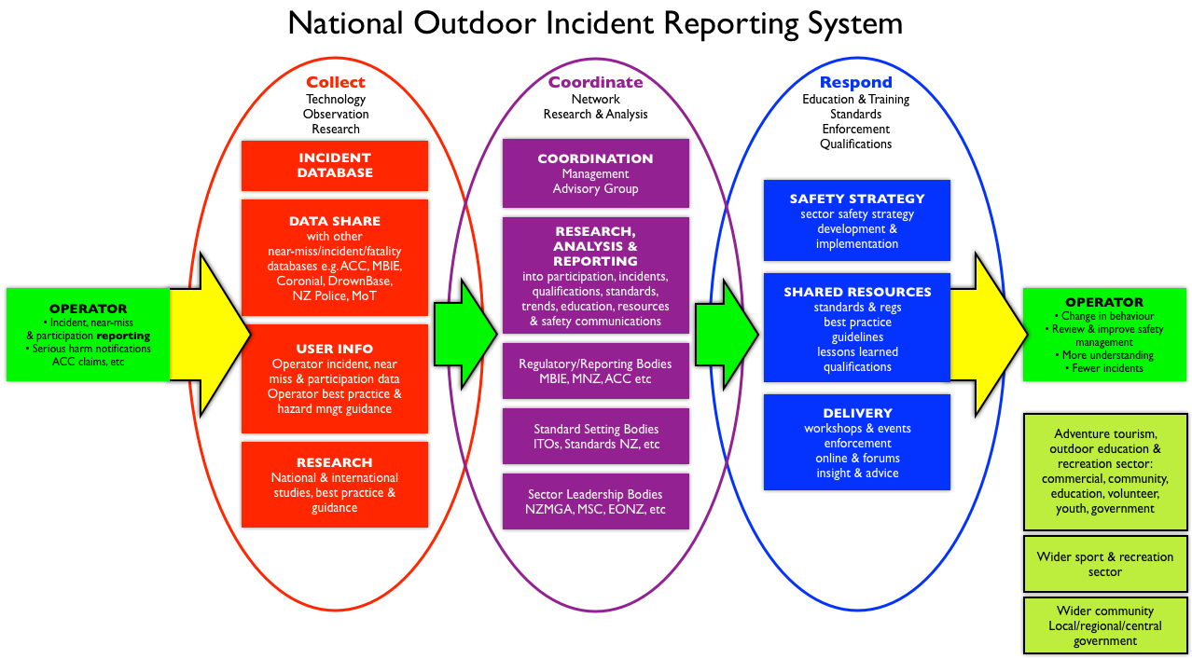

A larger version of this diagram is in Appendix 4.

# Process for Development

Outdoors NZ, in combination with MSC and other key organisations with an interest in the sector (including ACC, Sport NZ and EONZ), will proceed with this development project once we have MBIE approval. We suggest that the following project development process be considered:

| Action | Potential Timings |
| --- | --- |
| Draft of Strategic Proposal sent to MBIE | 20th May |
| Initial feedback from MBIE | By 24th May |
| ONZ and MBIE meet to discuss the business concept & next stage scoping requirements | Between 27th & 31st May |
| ONZ to complete an initial plan for delivery based on MBIE feedback. Plan to include overview of deliverables, costs of delivery and funding sources. | By the 19th of April |
| ONZ, MBIE and other stakeholders meet to develop clear deliverables and agree collaborative arrangements | By 19th of June |
| Confirm funding to complete the strategy and development | By 25th of June |
| Delivery of a detailed development plan for the IRS implementation project | Complete by 30th of June |

# Costing Overview

The next stage of the project would be to complete the development plan and business case for the technology solution, the operator engagement and education programmes and a plan for ongoing provision of the complete system.

This scoping phase would need to be comprehensive enough to provide a clear picture of what the overall solution will look like, as well as what and who would need to be involved in the creation and ongoing management. The aim would be to have this complete and in the hands of MBIE for review and feedback no later than 30th June 2013.

#### Scoping plan, complete by 30 June 2013

|  |  |
| --- | --- |
| Item | Cost |
| Scoping Activity | $15,000 |
| Project management (Mar-June 2013) including overheads | $15,000 |
| Collection of sector feedback | $4,000 |
| Travel and accommodation | $2,500 |
| Overall scoping cost | $36,500 |

#### Project delivery and implementation

|  |  |
| --- | --- |
| Item | Cost |
| Technology development | TBC |
| Building communications and education processes | TBC |
| Others to be clarified | TBC |
| Overall project cost | TBC |

#### Ongoing operations

|  |  |
| --- | --- |
| Item | Cost |
| Collection and synthesis of data | TBC |
| Co-ordination of responses | TBC |
| Responses | TBC |
| Overall project cost | TBC |

# Appendices

## Appendix 1 – The Adventure Activities Review Report

##### FINAL REPORT: Review of risk management and safety in the adventure and outdoor commercial sectors in New Zealand 2009/10

June 2010

#### IV. Key Findings

c. There are information problems

This situation is worsened by under-reporting of serious harm accidents, and inconsistent or poor methods of collecting information on them and collating that information.

d. Approaches to managing safety are inconsistent

There is no overall system that proactively identifies and addresses gaps and assesses whether they pose significant safety risks

#### V. Priority Issues to be Addressed

b. Whole of system issues

Activities and operations that pose unmanaged risks may not be noticed until accidents bring them to the attention of the safety agencies responsible. This is not appropriate for a sector, which by its nature involves exposing participants to higher risks and where failures can have an impact on New Zealand’s reputation.

There are information problems. A lack of data – including under-reporting of incidents – means that actual risk and safety trends cannot be determined. Additionally, information sharing across the whole sector is constrained by the fragmented nature of the sector and the jurisdictional split across three different agencies (Department of Labour, Maritime New Zealand, Civil Aviation Authority).

#### VI. Initiatives to Address the Priority Issues

##### ****Addressing information gaps****

j. Better information collection and collation

This involves three things:

* Collecting better information
* Collecting consistent information
* Improving systems of collation.

##### ****Collecting better information****

For all land-based and non-certified water-based activities this could involve collecting information through:

* The proposed registration scheme
  + Who in New Zealand offers land-based and non-certified water-based activities on a commercial basis, what activities they offer and where. Collecting business details through a registration scheme would be easy for agencies if entry requirements were introduced.
* Directing safety agencies (or tasking a new industry-led entity) to investigate activities in more detail
  + What risk management provisions are in place for each activity and what the risk management practices are amongst all relevant parties. This would determine if greater activity-specific intervention is needed. Directing safety agencies to investigate activities in more detail is likely to be resource intensive and would require a shift within agency baselines away from other agency activity (with implications for regulatory involvement with other high-risk industry sectors and activities). Tasking a new industry-led entity to do this work would require corresponding resources.
* A scanning function
  + Proactively identifying emerging activities and changes in the profile of existing activities. Agencies could be instructed to scan more proactively according to consistent criteria. Scanning could also be assigned to an overarching entity for the sector. The cost of scanning should be low, although directing safety agencies to undertake this would require a shift within agency baselines away from other agency activity.
* A database/reporting approach
  + Information on incidents that led, or could have led, to serious harm  accidents. Addressing the current information deficit about the number of incidents and accidents in the sector could help determine actual risk for each activity.
  + This approach could involve expanding and resourcing the existing National Incident Database managed by the New Zealand Mountain Safety Council. Information supplied to safety agencies could be integrated into that database also. An annual report could be produced to summarise the information gathered.
  + The database/reporting approach would require a gap analysis of the National Incident Database and resources to expand or re-design and promote it (low cost). Endeavours to integrate information from safety agencies would also take some re-alignment of agency resources (higher costs).
* A study-based approach, or incident surveillance programme.
  + As an alternative or complementary approach to the database/reporting approach above, an annual survey and report could be produced (possibly by a tertiary institute). The study-based approach or incident surveillance programme would require medium ongoing funding for research.

For all activities this would involve collecting information through:

* A participation study
  + Information provided through an annual survey and report. A participation study would address the lack of knowledge about how many people participate in adventure and outdoor commercial sector activities and the consequent inability to determine risk levels and serious harm injury rates.

Note that in terms of implementing this initiative, defining the boundaries of the adventure and outdoor commercial sectors could be difficult.

##### ****Collecting consistent information****

This would involve aligning reporting requirements so that all relevant safety agencies gather consistent information on reported incidents. It would include the Department of Labour, CAA, Maritime NZ, ACC, the Ministry of Economic Development (MED) and possibly others.

This would require a lead agency or mechanism to coordinate changes to the way data is collected and the type collected. It would provide better quality and comparable information that could be analysed so that lessons from incidents might be learnt. However, it may be difficult to achieve consistency across agencies because current data is collected to meet different legislative requirements.

##### ****Improving systems of collation****

So that the adventure and outdoor commercial sector can learn from incidents and accidents, systems of collation need to be improved. This could involve the following:

* Ensuring that information on incidents and serious harm accidents reported to the Department of Labour and ACC is comprehensive, the outcome is clearly identified and the information can be collated
* Ensuring that commercial and recreational incidents and accidents can be differentiated and collated
* Ensuring that the activities in which incidents and accidents occurred can be easily identified and collated
* Requiring an annual report (public) for the adventure and outdoor commercial sectors.  This initiative would allow good quality analysis of reported incidents that led, or could have led, to serious harm accidents.

It would be appropriate to undertake these enhancements after the proposed legislative changes to the definition of serious harm have been introduced.

This initiative would require resources to improve existing Department of Labour and ACC incident and accident reporting and recording systems.

This initiative would be relatively easy to implement. However, it would divert resources from other agency activities.

## Appendix 2 – Key Components to Improving Safety Culture

### Participation Data

A key measure is the overall reduction of incidents and accidents per 1000 people participating in outdoor activities. While overall participation figures are variable and difficult to confirm, targeted reduction of incidents/accident related to specific areas of activity is a practical way of moving this forward.

### Clearer Information

Information needs to be collected and organised in a way that makes it clear and easy to use. This will be driven in part by the evaluation and analysis criteria needed. In addition it is important that information is organised and packaged in a way that allows operators to easily use it.

#### Information Collection

This process needs to not only be simple and easy to do in order to reduce barriers to completion it also should provide direct value back to those who provide data. This could be achieved by replacing or integrating their current incident and accident registers with a national database and collection tool.

#### Information Summarising

It is important that whatever is presented back to the sector through this process is in a form that makes it readily usable and drives appropriate responses from those receiving it. To achieve this it will be important to identify what is most likely to trigger the appropriate responses and how best to achieve this given the tools available.

It is likely that information will be distributed through a number of channels. As part of initial planning there will be some clarification of the most effective ways to provide information to the different elements of the sector and the co-ordination group.

#### Mitigation and Response Libraries

Once information and suggestions related to mitigating risks and reducing potential hazards have been created then these need to be stored so they are readily retrievable and available when needed. This will extend existing sector knowledge bases and ideally should be able to integrate international learning as appropriate. These libraries will require records to be maintained, updated and retired as needed.

### Key actions to improve the national reporting safety culture

1. No blame (anonymity of near-miss reporting)
2. Sharing information
3. Creating a communications loop, ensuring there is value to participation because people get tangible and actionable information back
4. Support from all those involved including Government agencies, reduction in fees for positive achievement of results, tying funding to compliance, safety audits will follow up on this information and peoples contributions
5. Incentivisation and compulsion through regulatory, sector & peer actions (carrot and stick)
6. Timely reporting and information/knowledge sharing
7. Meaningful, usable information and advice

## Appendix 3 – Technology Overview

#### Drivers for the technology component

Key goals for any technology processes are:

##### Incident reporting and information collation

1. Information is collected in a timely way, analysed against key indicators and a usable report, with actionable outcomes where appropriate, is available soon after an incident occurs.
2. The information reporting would be easily visible at both a collective and individual level so that people are able to respond quickly to identified trends or specific incidents.
3. Recording and reporting of incidents are as easy and convenient as possible.
4. Information is made available to the sector in a way that is convenient and easy for them to gain learning from an incident and change behaviour
5. Incident recording is available for the organisation or individual involved and can be appropriately disseminated into the wider outdoor community
6. Regulatory obligations are simplified and supported by using the system
7. The system balances the process appropriately so that information about those involved is shared at a level that encourages participation.

Currently, the incident information collected is limited and the response is often not conducive to supporting or enabling better practise.

* Those using the current National Incident Database
  + Rarely get timely information, particularly where activities are seasonal
  + Receive information, not education
  + Information difficult to understand trends
  + Limited distribution of information, needs greater incorporation of education and lessons learnt
* Those not using the National Incident Database
  + Often simple paper processes if anything. Usually driven by a requirement to report to a statutory body

##### Communications technologies that could be utilised

1. Use of social media tools to disseminate information
2. Timely updating key communications and forums
3. Automatically sending e-mails or prompts to the people who need to be informed
4. The maintenance of online information libraries and resource stores
5. Tying into other agencies so information is bundled

#### Options for closing the information gaps

* Getting those who don’t have incident logs involved
* Getting people to report near misses
* Publishing Hazard or Safety alerts to the wider sector, face booking, twitter (Social Media) and integrating comments to provide richer feedback and ideas
* Developing education programmes using workshops, information and packages that are based on identified trends
* Supporting industry wide events for sharing/developing safer practise using existing and new networks

## Appendix 4 – Detailed IRS System Diagram

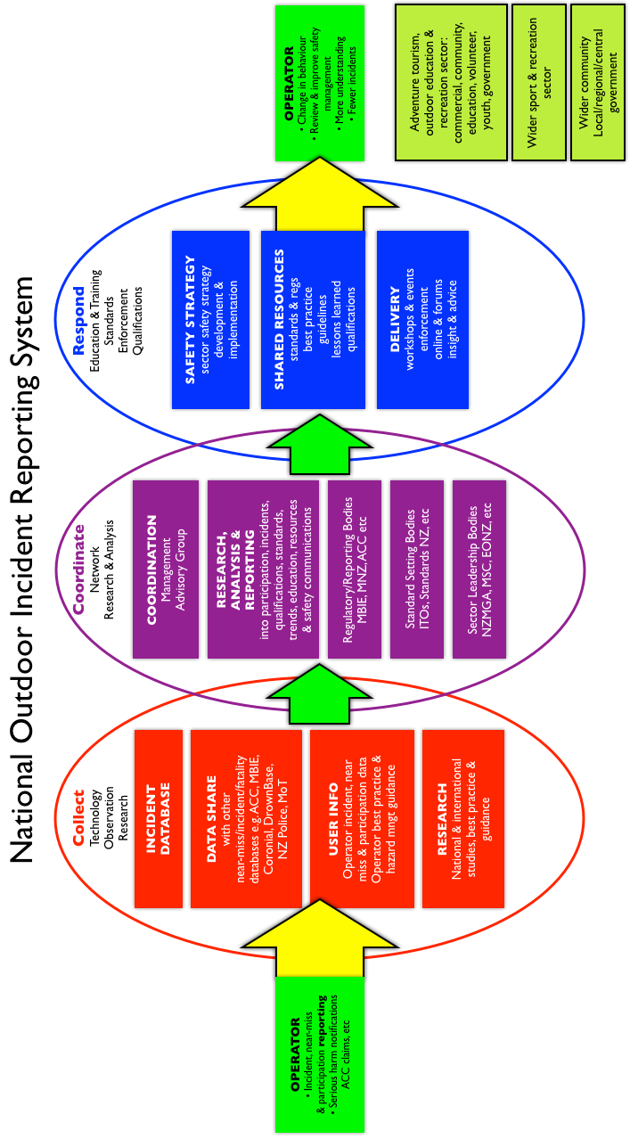

## Appendix 5 – Case Studies

### Ski Fields information

The New Zealand ski industry is currently using a shared data collection system to capture and report incidents and accidents on ski fields. All incident data is annually reviewed and reporting.

As part of the reporting, data is summarised and presented in a way that assists ski field operators to identify potential hazards. The industry collectively has set a number of targets related to safety and reduction in injuries based on these reports.

As part of the process clear outcomes are put in place. The outcomes include a specific measure of current occurrences with the expectation that these will be reduced.

From there a strategy is put in place to reduce the specific incident. This strategy is developed using input from the industry with key fields recommending and testing particular solutions.

Steps in ski field process

1. Data is collected using the NID
2. The data is summarised and reviewed at the same time that participation figures are added to provide a baseline
3. Further analysis is completed to provide guidance and feedback on incidents and previous responses
4. A sector body defines in consultation with the sector where they will focus and what actions are suggested
5. The action plan is confirmed with the sector
6. Other stakeholders such as ACC are invited to incentivise positive outcomes
7. Responses are acted upon and monitored then modified through the same process

### NZ Forestry Industry

The NZ Forestry Industry Operators Association also runs an online incident and accident recording system.

In addition to this system they maintain a library of information related to specific incidents and accidents. This library contains recommended mitigations or ways of avoiding similar incidents in the future.

The recommendations are held as PDF files linked to the specific incident. No data management occurs for the library, though all have reference details which allow them to be retrieved quickly.

Data is collated and analysed by an independent organisation and shared out to different industry organisations as required.

Some further analysis of this process and that of the aircraft and maritime industries is still to occur.